CA2 Individual Report
Name | Goh Kun Ming
Student Id | P2415691
Class | DAAA/FT/1B/02
Github Repository URL | https://github.com/ST0503-BED/bed-ca2-GohKunMing
Github Account ID | GohKunMing

For each competencies, find links to pull requests/commits/files that demonstrate the completion of the requirement. Replace each “?” with your Self Rating.
For Self Rating, you may rate yourself accordingly if you feel that you:
- Have little or no understanding. and did not attempt the requirement
- Have limited understanding of the specific competency
- Have basic understanding and only able to replicate examples from tutorials/practicals.
- Have adequate understanding and can extend from what you have learned to fulfil specifications.
- Have solid understanding in the specific competency, able work on the requirement without much references.
- Have excellent understanding and implemented the requirement according to latest industry guidelines, best practices and documentations.

Important
- You are require to provide for each competency:
  - A brief description
  - One or two of your best implementations with URL link to respective repository request/commits/files.
    - Below is an example of linking to specific script file
https://github.com/expressjs/express/blob/master/examples/static-files/index.js
  - The implementations may come from Section A or B.
- You are to ensure the hyperlink in this document works. Failure to do so will result in a 50% deduction of marks.
- You are to provide screenshots using POSTMAN to perform API test.

No. | Competencies | Describe What Was Done | Self Rating
1 | Backend Server | I set up an Express.js server with separate routes for each feature. Each route processed incoming requests, validated the data within the controller, then executed database queries via SQL statements in the model. The server sent back appropriate JSON responses with correct status codes (e.g., 200 for success, 404 for not found). This ensures a clean separation of concerns and makes it easy to debug. All these were mainly done during CA1 which provided a good skeleton for the front end to be integrated to.  Reference: inventoryController, petController | 5/5
2 | Functionality | All implemented features match the project requirements, such as user registration, login, and challenge tracking. I tested each feature extensively to confirm they work as expected. I also worked on the gamification which is extremely complex with multiple relationships to be drawn. I was able to test and ensure that the gamifications was able to function as intended and also work towards the main goal of fitness. There were also extra functions which served no purpose to the fitness challenge but were there for aesthetics such as credits and other designs.  Reference: mainRoutes | 5/5
3 | Code Quality | I used consistent naming conventions, modularized logic into separate files, and documented complex functions. I maintained a clear folder structure, separating controllers, models, and routes for readability. I also ensured that callback functions were named appropriately and routes were named logically so as not to create confusion or have conflict with other routes. I also ensured that the data base data column followed convention such as using singular.  Reference: userController.js | 5/5
4 | Modularity | There were multiple reusage of middleware functions excluding the JWT middlewares. These middleware perform simple operations such as checking if the user id is valid or the item id is valid so as to produce a layer of error handling throughout the backend. There was also the reusage of frontend codes as a similar theme is being followed which implies that the same CSS script can be reused since not much difference need to be made and consistency needs to be enforced.  Reference: Homepage.css, userController.js | 5/5
5 | Error Handling | For any issues (database errors, invalid inputs), I returned clear error messages alongside the appropriate HTTP status codes (e.g., 400 for bad requests, 500 for server errors). I also used middleware for global error handling, logging the stack traces, and displaying user-friendly messages to the client. This was mainly done in CA 1 and not much was changed as most of the errors are still relevant from CA1.  Reference: challengeController.js, itemController.js | 5/5
6 | Documentation | I wrote a detailed README explaining how to install dependencies, set up environment variables, and run the project. I also added concise comments near complex functions and SQL query to clarify their purpose. Configuration files were also commented to help future developers understand each setting. These will allow for other developers to work on the project in the future should there be a need for expansion and further development. Less time will also be needed for communication between developers as comments are helpful.  Reference: README.md | 5/5
7 | JWT for Authentication | Upon successful login, a JWT is generated with a secret key and an expiration time. The frontend stores this token locally and sends it in the Authorization header. Protected routes verify the token in middleware to confirm identity.  Reference: inventoryRoutes.js, petRoutes.js | 5/5
8 | BCrypt for Password Hashing | I hashed passwords with bcrypt using an appropriate salt round count. On login, the incoming password is hashed again and compared to the stored hash. This secure approach protects user credentials while balancing server load. I also ensured that users have extremely limited access to the webpage when they are not logged in.  Reference: mainRoutes | 5/5
9 | Frontend to Backend HTTP Requests | I used fetch to send HTTP requests from the frontend, adding headers with the JWT for authentication. Responses were handled with utilising the returned object and using either textcontent or innerHTML to allow for dynamic content throughout the webpage  Reference: inventory.js, challenge.js | 5/5
10 | HTML & CSS Proficiency | I used semantic HTML5 tags for clarity (e.g., <header>, <section>, <footer>), and organized elements using Grid. Styles were put in separate CSS files. I applied consistent color schemes, fonts, and spacing to maintain a polished, cohesive design across pages. I also used animations and transitions for come pages so as to create a more visually appealing webpage and design for the users.  Reference: homepage.css, homepage.html | 5/5
12 | JavaScript and DOM Manipulation | I listened for user events (clicks, form submissions) and fetched data from the backend. Results were appended to the DOM without full page reloads, creating a smoother user experience.  Reference: inventory.js, challenge.js | 5/5

Updated Entity Relationship Diagram
ERD
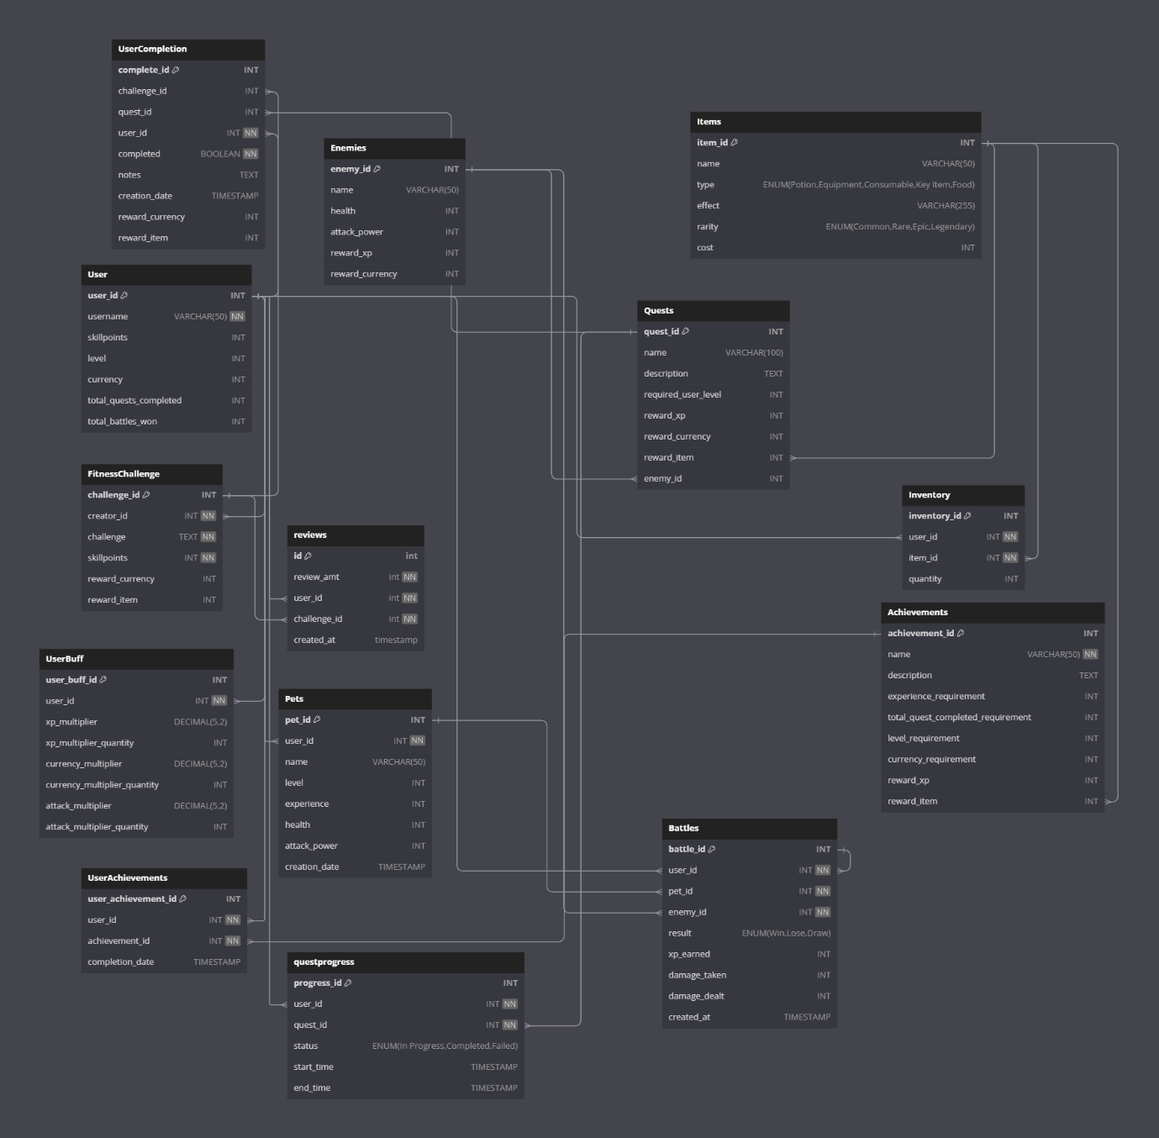

Video Demo
No. | Label | Screenshot
1 | Video demo for unregistered user | https://youtu.be/py7ro7UfjHA
2 | Video Demo For Logged in user | https://youtu.be/vtZKIt1wOfU
3 | Video Demo for Complex Features | https://youtu.be/Un_DbPT2wHI

